Deconstructing HCI & Computer Graphics

Mini Assignment | Slide 1 of 2 — HCI Focus
App Chosen:__GOOGLE EARTH ___________________________________________________________
Screenshot 1 — HCI (Interaction) Focus
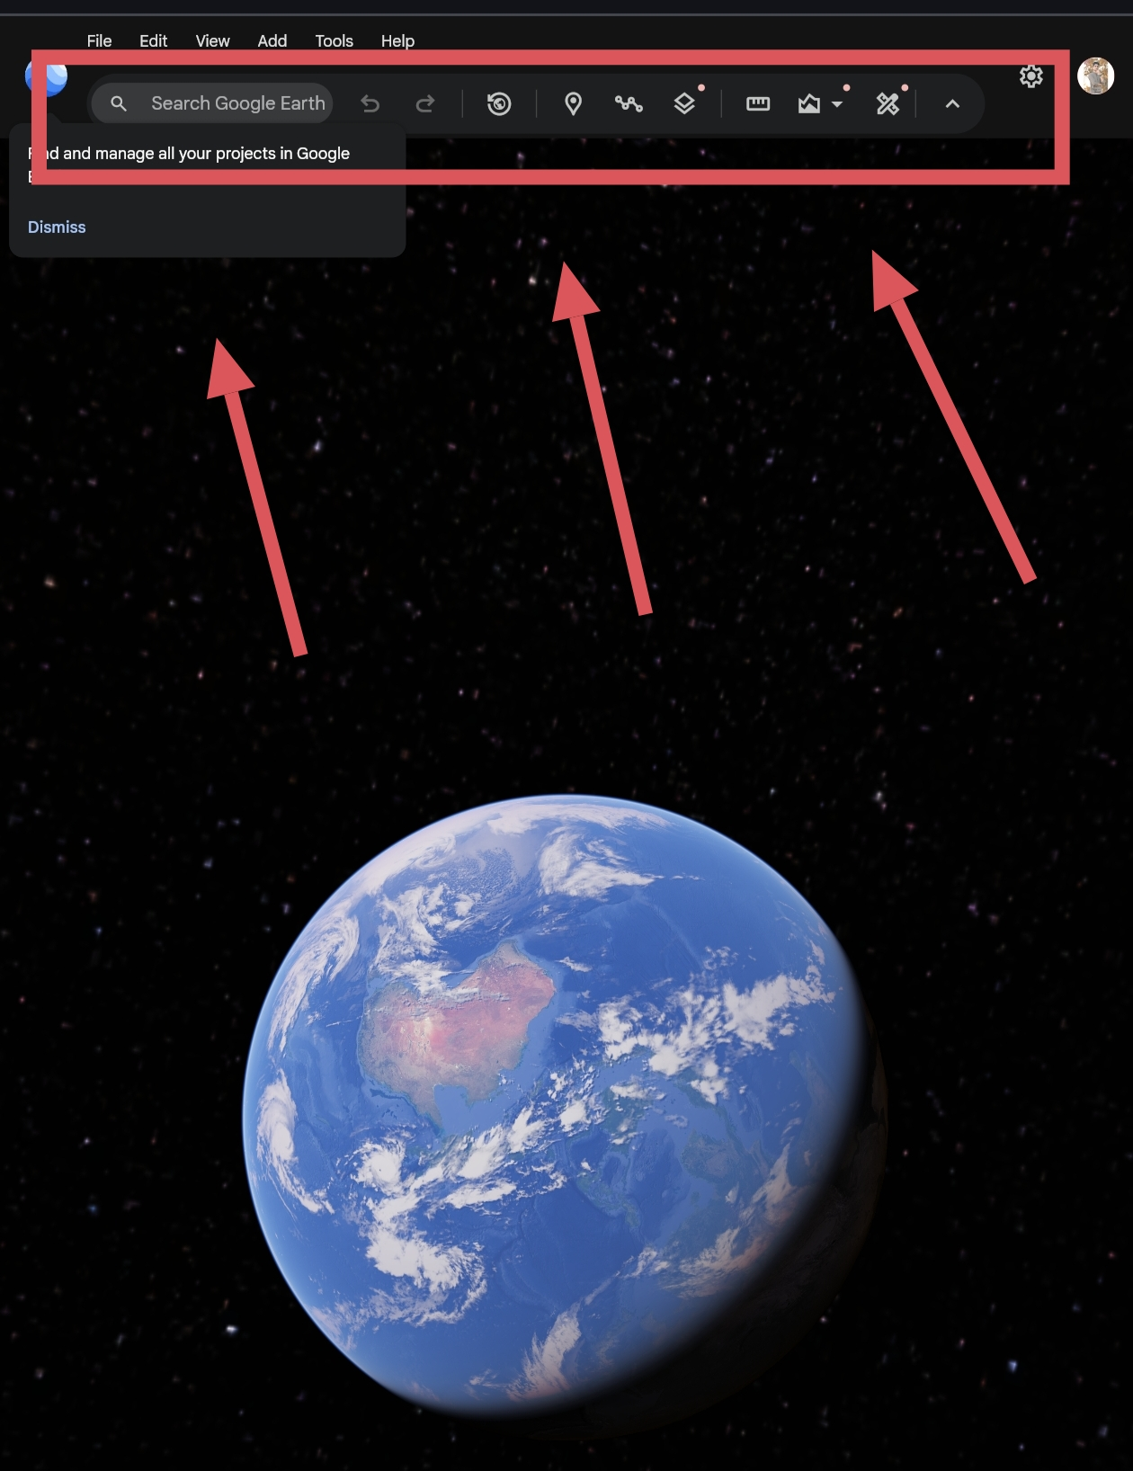
[ PASTE SCREENSHOT HERE ]
Screenshot showing menu buttons / controls / feedback text

Annotate & explain 3 interaction elements:
Example below uses Google Earth — swap in your own app/screenshot and rewrite these in your own words.
1. Search bar (top-left)
Lets the user type any address or landmark and jump straight there instead of manually panning around the globe to find it.
2. Zoom / tilt control (bottom-right)
A simple +/- slider and compass dial give direct, visible control over the camera, so the user doesn't need to guess mouse gestures to explore in 3D.
3. Layers panel (left sidebar)
Toggles like Borders, Roads, and Photos give clear on/off feedback, so the user always knows what data is currently being shown.
Deconstructing HCI & Computer Graphics

Mini Assignment | Slide 2 of 2 — CG Focus & Reflection
Screenshot 2 — CG (Rendering) Focus
[ PASTE SCREENSHOT HERE
Screenshot showing lighting / shadows / mesh / camera / texture

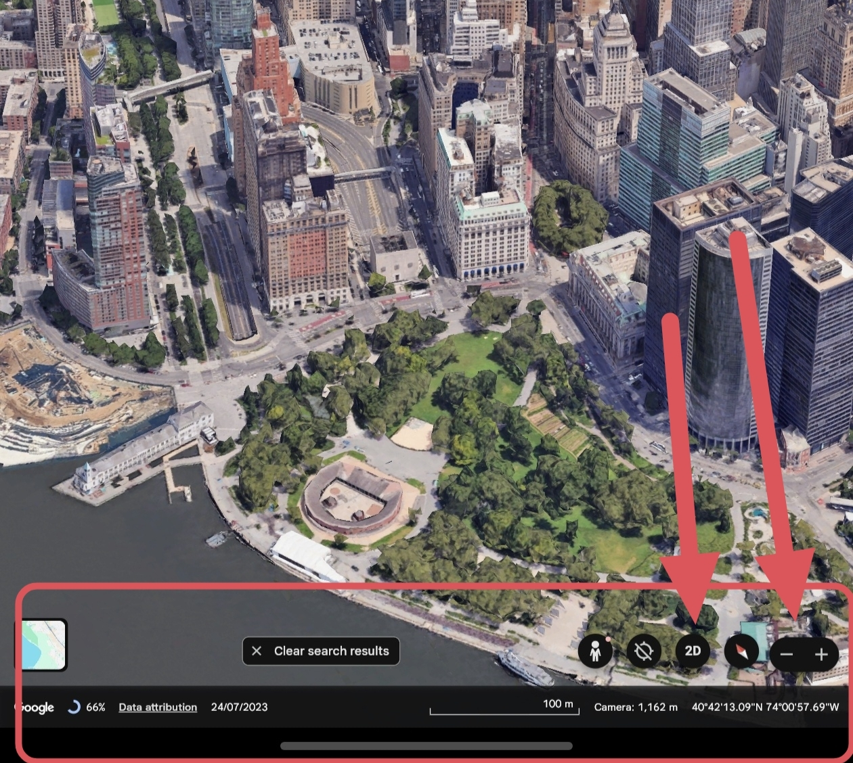
Annotate & explain 3 rendering elements:
1. Shadow & lighting on terrain
Real-time sun-angle shading gives mountains and valleys a sense of depth, so flat satellite data actually reads as 3D
landscape.
2. 3D building meshes
City buildings are rendered as textured polygon meshes rather than flat map icons, which is what makes tilting the view
feel like flying over a real city.
3. Perspective camera view
As the user tilts or zooms, the camera uses perspective (not orthographic) projection, so distant objects shrink naturally
and the scene feels believable.
Reflection Questions
1. How does the Computer Graphics quality help or hinder the user's ability to interact with the software?
Good lighting and realistic terrain actually help here — shadows and shading make it much easier to judge distance and
elevation while navigating, so the user relies less on labels and more on visual cues. The tradeoff is that heavier rendering
can slow the app down on older devices, which briefly gets in the way of smooth interaction.
2. What is one simple HCI change you would make to improve the user interface?
I'd add a small on-screen "reset view" button. When you tilt and rotate for a while exploring in 3D, it's easy to lose orientation,
and right now there's no quick way back to the default straight-down map view without manually dragging back.
Mini Assignment: Deconstructing HCI & CG in Daily Software Page 2

